Nature uses precise control through molecular recognition and self-assembly processes to endow biopolymers with a variety of properties, e.g., mechanical strength, charge generation, light harvesting, directional energy and charge transport, and coding and storage of information. Precisely controlled primary structures—i.e., regiospecific sequences of monomer units—play important roles in biopolymers by locating key functional groups—e.g., those imparting unique electronic and molecular recognition properties—in a manner that determines the secondary and tertiary structures of the biopolymers. The late 20th century ushered in an era of unprecedented control in the design, synthesis and characterization of complex molecules. It heralded major advances (1) in carbon-carbon bond-forming reactions, (2) in our abilities to introduce functional groups with precise stereochemistries, and (3) in spectroscopic techniques that enable the study of structures and reactions at small dimensions and on short time-scales. It also witnessed the advent of noncovalent synthesis (strict self-assembly) and supramolecular assistance to covalent synthesis, i.e., template-directed synthesis. During the same time period, molecular biologists were developing a fundamental understanding of how nature, by relying upon DNA, RNA, proteins, and glyco-conjugates, accomplishes a diverse set of tasks using, for the most part, very simple bond-forming reactions and a small pool of monomers. The take-home message from biology emphasizes the importance of of templation. We plan to make structurally precise heteropolymers by three different routes – namely:
- Employing templation and supramolecular assistance to covalent synthesis to make wholly synthetic, long-chain, sequence-controlled heteropolymers;
- advancing the capabilities of thermodynamically controlled metathesis-based polymerization techniques to assist in the efficient production of these heteropolymers;
using precise photodeprotection methodologies to deprotect the side chains on a polymer backbone with single-site control of the deprotection chemistry to impart patterns of stored chemical information upon the heteropolymer.

. Synthesis of Templates. Nucleic acids serve remarkably well as templates for the synthesis of sequence-controlled heteropolymers, including DNA, RNA and proteins. The chemistry of nucleic acids is, however, limited by the fact that DNA and RNA each use only four bases to encode sequence information. We propose to extend the concept of macromolecular templating to entirely new chemical systems, by designing artificial protein templates characterized by site-specific binding of monomeric building blocks that can be converted efficiently to polymeric forms in the bound state. Proteins are attractive in this regard because of the diverse chemistries of the 20 amino acid side chains, and because recent developments have led to methods for efficient incorporation of several dozen non-canonical amino acids. The diversity that becomes available in this way provides a basis for ordering diverse sets of monomers through engineered host-guest interactions. The use of artificial proteins allows control of binding-site spacing, secondary structure, and molecular flexibility in the template.

The templates of primary interest in this work will consist of periodic polypeptides characterized by precise control of length, sequence and stereochemistry. Over the last 10 years, Tirrell’s laboratory has prepared many such polymers, some with degrees of polymerization as high as 700. Yields in such syntheses are surprisingly good; gram quantities can be readily isolated from laboratory-scale bacterial cultures. Sequence control allows the design of polymers, soluble either in water or in organic solvents, as well as control of molecular rigidity. The initial templates will consist of helical polypeptides, which exhibit persistence lengths on the order of tens of nanometers, in order to impose an appropriate geometry for sequence-regulated polymerization of bound monomers.

Polypeptide templates will be prepared via expression of artificial genes in bacterial cells, as shown schematically in Figure 2. The use of artificial genes in this context offers three critical advantages: (1) it ensures the precise control of structure required of an effective molecular template, (2) it facilitates parallel preparation of libraries of alternative templates, and (3) it allows recovery, amplification and evolution of the underlying coding sequences. If one is to achieve not only synthesis, but also evolution, of sequence-controlled heteropolymers, access to libraries of amplifiable coding sequences is essential.

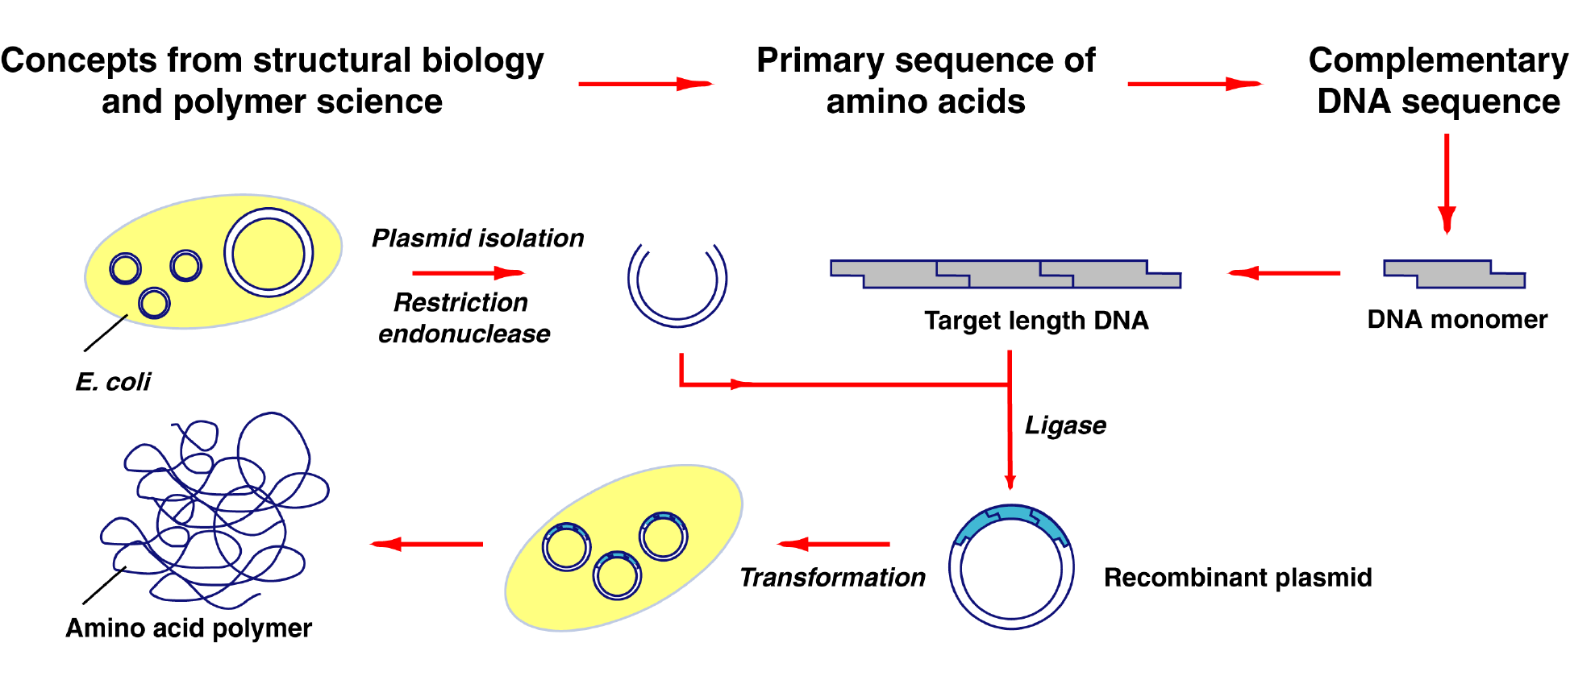

Figure 2. Schematic illustration of template synthesis. The sequence of the artificial protein template is designed with consideration of the chemistry and geometry needed for effective templation, as well as consideration of solubility and conformational properties. The sequence is encoded into an artificial gene, which is then cloned and expressed in a bacterial host. This method provides near-absolute control of molecular architecture, access to a wide variety of side-chain functionality, and a mechanism for selection, amplification, and evolution of sequence.

2.1.2. Recognition Motifs. In principle, a variety of recognition motifs could be used to assemble the desired monomers along the backbone of the template. These could be based upon (1) simple electrostatic, (2) hydrogen bonding, (3) arene [π–π] stacking, and (4) metal-ligand interactions. Only one such type of interaction, however, will be described here in order to demonstrate the approach – namely hydrogen bonding. By virtue of their selectivity, directionality, and tunable strength, hydrogen bonds are the obvious candidates for initial investigations. The two orthogonal hydrogen-bonded molecular-recognition pairings that we will employ (Figure 3) at the outset are (1) the guanine·cytosine (G·C) DNA/RNA base pair, and (2) the ‘threading’ interaction of secondary dialkylammonium ions through the cavities of appropriately-sized crown ether derivatives to form9 pseudorotaxanes. In general, such complexes are comprised of a rod-like component that is encircled by one (or more) complementary macrocycles. Perhaps one of the best understood pseudorotaxane systems is that which utilizes the interaction between dibenzylammonium ions and dibenzo[24]crown-8 (DB24C8) macrocycles, and hence the reason for its incorporation into this proposal.

2.1.3. Polymerization Methods. The methods chosen for polymerization of the monomers that are assembled along the template must proceed within the bounds of certain criteria. Specifically, the process must (1) be tolerant of, and orthogonal to, the functionalities employed in the molecular recognition events, (2) exhibit low termination and chain transfer rates, (3) be reversible, in order to allow self-correction of errors, and (4) display sensitivity to concentration effects. The first two requirements are self-evident. Factors 3 and 4, however, are the key to the success of this approach in its most general embodiment. Ring opening poly-merizations are the most appropriate for these processes since these reactions involve a ring/chain equilibrium14 and are characterized by having a critical concentration below which the monomers will not polymerize. Therefore, if the bulk concentration in such a reaction is below the critical concentration, the monomers will only be present above their critical concentration when they are assembled on the template polymer. In such cases, we may forego the step in which the catalytic species is anchored to the template and allow it to roam freely in solution. Crucially, monomers will be chosen such that they are not highly strained in order that the polymerization is reversible, thereby allowing the units along the template to equilibrate into the most thermodynamically stable sequence. Furthermore, in some situations, the interactions of the assembly may be sufficiently strong such that excess monomer can be removed before polymerization. Under these circumstances, non-ring opening reactions can also be utilized.
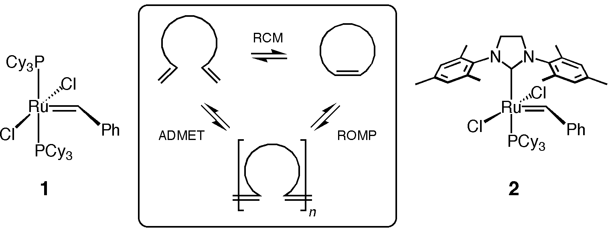

Figure 7. Ruthenium alkylidene catalysts 115 and 216 are both capable of achieving the olefin metathesis transformations outlined in the central box (ROMP: Ring-Opening Metathesis Polymerization, RCM: Ring-Closing Metathesis, ADMET: Acyclic Diene METathesis).

Ruthenium alkylidene-catalyzed olefin metathesis—ROMP and ADMET—provide polymerization methods (Figure 7) that fit most of the requirements outlined above. ROMP reactions of cyclic olefins with moderate ring strain are reversible and have significantly high critical concentrations. ADMET can be run under conditions with non-volatile additives to give a system that exhibits an apparent critical concentration that is controlled by the concentration of the additives. Although the primary focus of our approach will center upon these olefin metatheses, in principle other ring opening reactions, such as those of lactones and ethers, can show the desired characteristics when there is proper functional group compatibility.

2.1.4. Template Release. Once the duplex of daughter and template chains has been formed, strand separation must be accomplished in order to allow turnover. In an approach where the catalyst is initially anchored to the template via a disulfide bond, the newly-formed polymer retains this covalent linkage to the template. This bond can be cleaved under reductive conditions (e.g., NaBH4), leaving only the noncovalent daughter/template interactions. Subsequently, an approach analogous to that encountered in the polymerase chain reaction (PCR) protocol, where hybridization and primer extension occur at low temperature and the product duplex is subsequently melted in a high-temperature cycle, could be adopted here. Upon elevation of the temperature, the hydrogen bonding interactions grow less and less significant, and the daughter polymer ‘melts’ away from the template and can be washed away. As a consequence of its attachment to a solid support, the protein template remains behind and, after cooling, the system can be recycled upon the addition of further catalyst and monomers. Alternatively, the hydrogen bonding may be disrupted upon the addition of an excess of polar solvent, which may also serve as the media in which the daughter polymer is washed away, to leave behind the template for recycling.

2.1.5. Modification of Daughter Polymers. The protocols outlined in the previous subsections will provide a demonstration of the approach. The procedures described in Figure 8 provide a way to generalize the materials prepared. Required functional groups can be installed by either covalent or noncovalent interactions with the daughter polymer once the molecular recognition components have been cleaved. As discussed in Section 2.1.2., the directionality of the ester linkage will be used to impart a pattern of hydroxyl and carboxylic acid functional groups—a sequence inherited from the protein

2.4. Post-Polymerization Functionalization
Some of the potential applications of sequence-controlled polymers include those based upon optical and electronic properties, e.g., photorefractive, photovoltaic and optical limiting applications. For example, we are interested in examining whether careful control of block length in copolymers can lead to different phase separation behavior in photovoltaic-type polymers, and in comparing the electronic behavior of polymers with sudden and gradual inter-gradation between blocks (i.e., ...AAAAAAAAAAABBBBBBBBBBB... vs. ...AAAAABAABABABABABABBABBB...). For these applications, the pendant groups attached to monomers synthesized by the routes described in Sections 2.1–2.3 will be required to have specific electronic properties. We have already synthesized hydroxy-functionalized bis(triarylamines) (Figure 18c,d)23,24 – suitable for transporting holes in photorefractive and photovoltaic devices, or to act as donors in optical-limiting systems – and hydroxy-functionalized photorefractive chromophores (Figure 18a,b).25 Fullerenes will also be useful as components of this sort of material; one of the several known carboxylic acid derivatives of C60 (for example see reference26) will be useful for linking to polymers with X hydroxy groups. Other groups useful for these applications involve electron transport moieties such as suitably functionalized oxadiazoles (for example those shown in Figure 18e,f and previously used in reference27) and dioxaborines. For optical limiting applications discussed below, we will incorporate acceptors such as those shown in Figure 18e–h and one and two-photon sensitizers, such as those shown in Figure 18 (c,d, and i, where n = 1–3). Other groups with specific optical and electronic functions are described in Section 3.2.

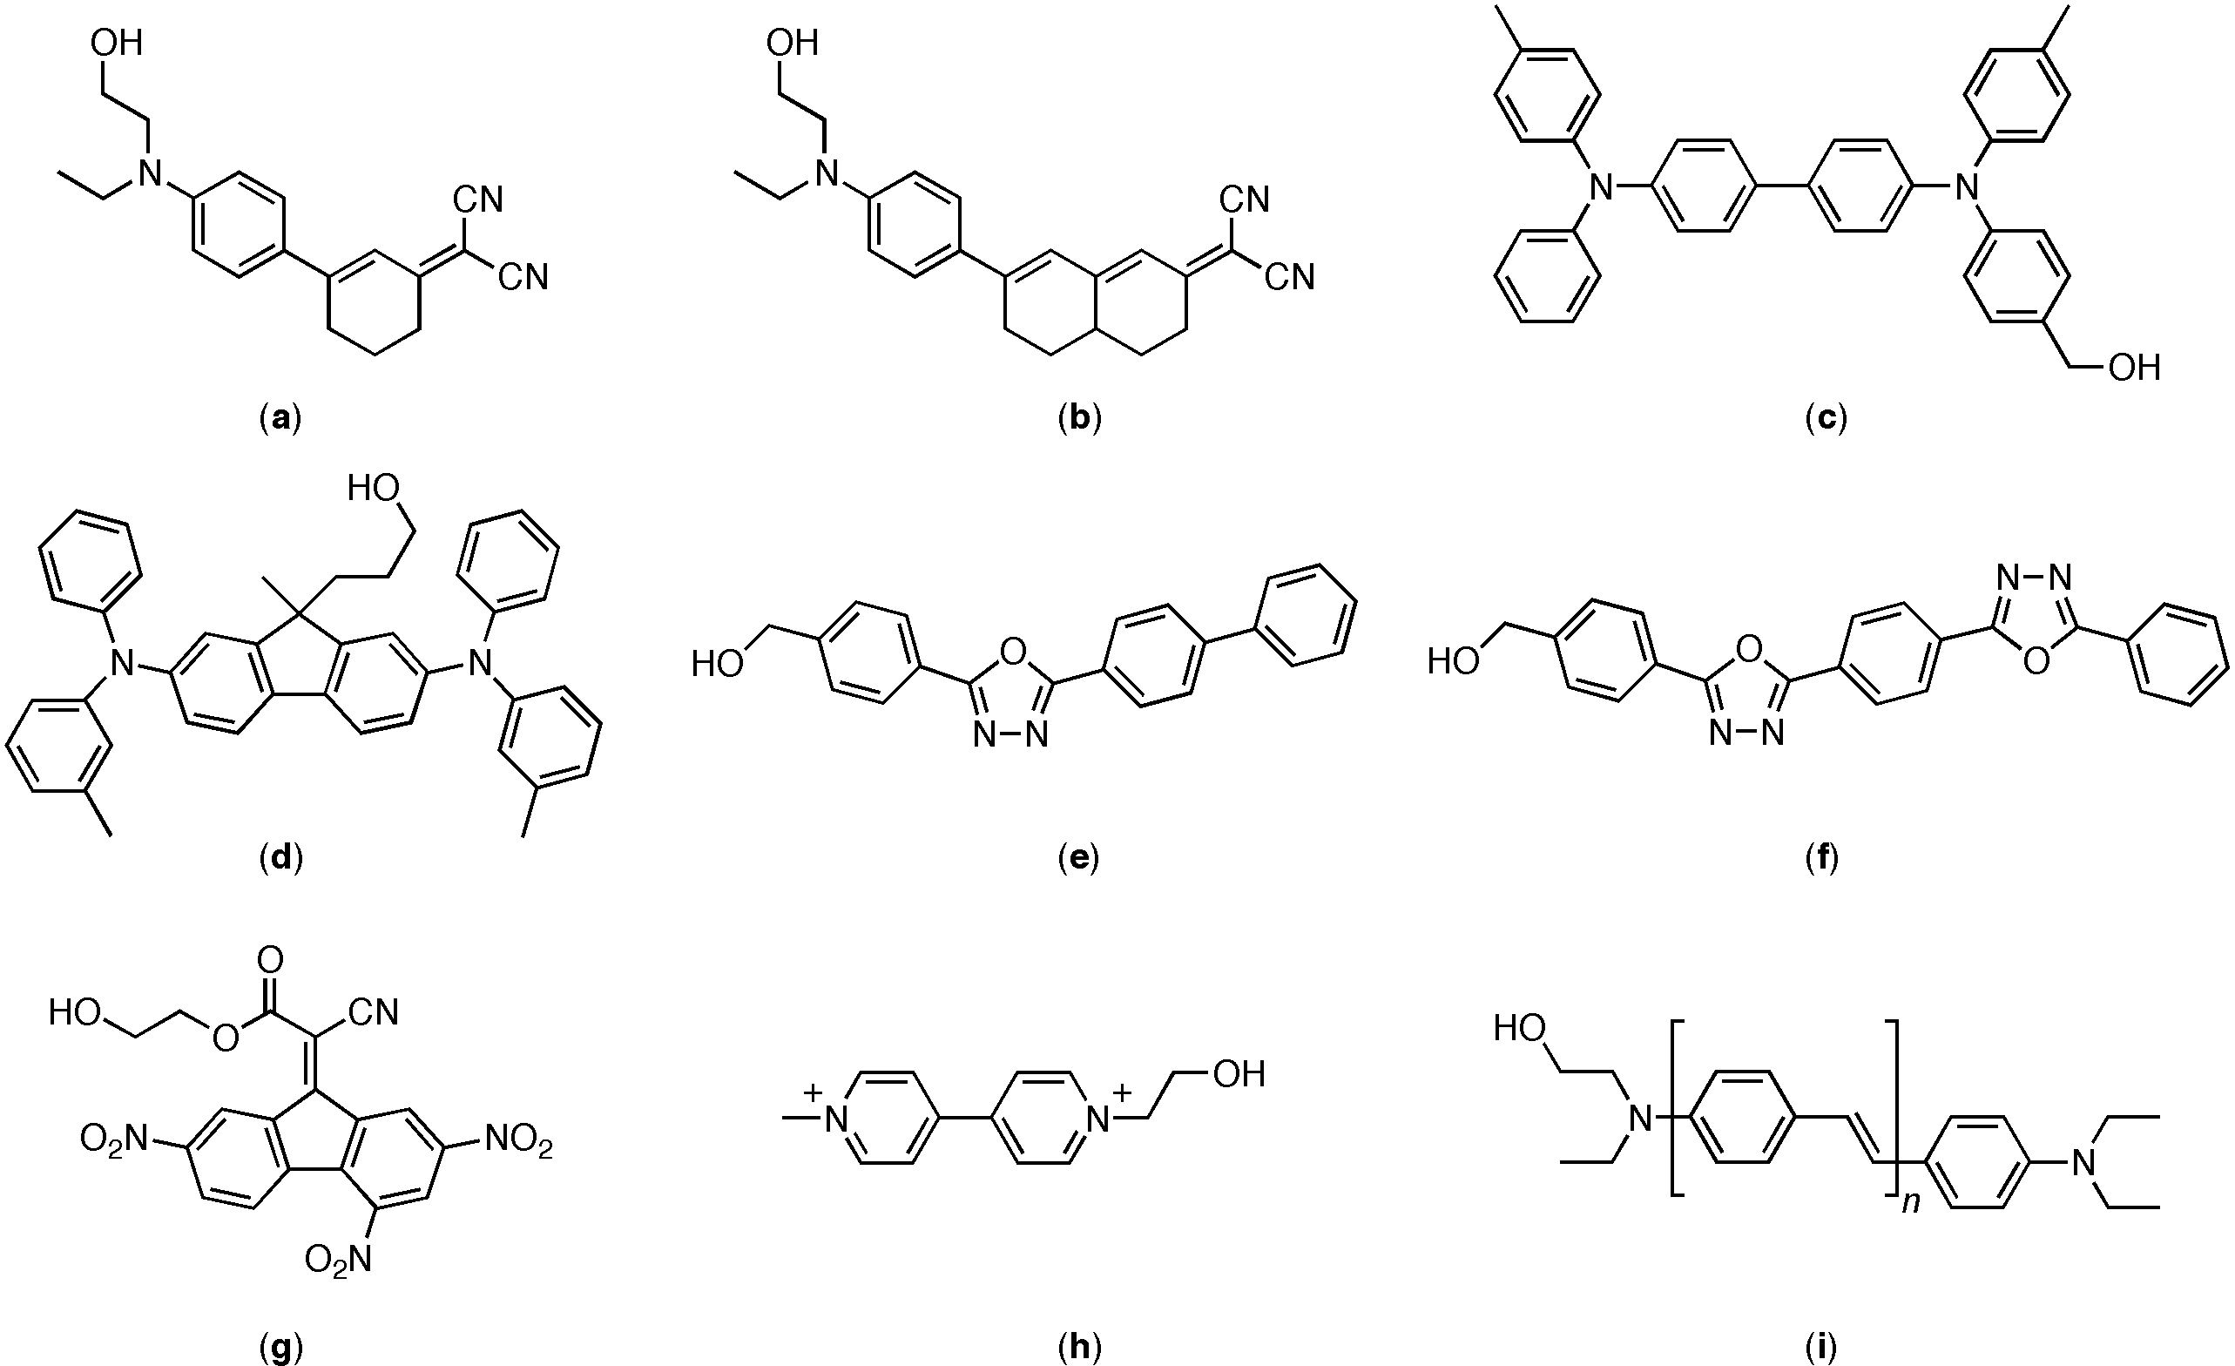

Figure 18. Side groups functionalized for attachment (as groups “A” and “B”) to polymers for electronic and optical applications; Marder et al., have synthesized the photorefractive dyes shown in (a) and (b),25 and the amines shown in (c)23 and (d).24 The oxadiazole shown in (e) has previously been reported,27 and that in (f) should be accessible by a similar route. Compounds (g–i) will be synthesized in this program for optical limiting applications.

3. Characterization and Applications of Structurally Precise Heteropolymers
3.1. Structural Characterization
Evaluation of the effectiveness of the proposed synthetic methods will largely be accomplished through mass spectrometry, using techniques such as MALDI-TOF. Initial experiments will determine the molecular weights and molecular weight distributions of the templated heteropolymers, and will correlate those parameters with the characteristics of the templates used in synthesis. Sequence analysis will be accomplished by reversal of the metathesis polymerization through the use of excess ethylene followed by mass analysis of the resulting fragments. Analogous methods are now widely used to sequence proteins by mass spectrometry.

3.2. Optical and Electronic Characterization and Applications of Structurally Precise Polymers
As a test-bed to study the degrees of control on structure and its impact on properties, we will study energy transfer and fundamental photonic, electronic and molecular recognition processes such as charge transport, photogeneration of charges, light emission and energy transfer. We will determine how processing impacts (1) the performance of ultra-high sensitivity sensors and (2) the fabrication of lightweight photovoltaic cells for mobile power applications, (3) macromolecular memory systems, as well as (4) optical limiting applications. These processes are highly sensitive to the distance, orientation, and electronic couple between various groups and therefore can provide information about the structures of the heteropolymers. The newly synthesized materials, with controlled structure and function, will therefore be processed into solid films that will be subjected to various optical and electrical characterization experiments described below. Simultaneously, these materials will be incorporated into organic electronic and photonic devices that are relevant to DoD objectives - for example, light-weight solar cells and plastic organic electronics. The performance of these devices will be compared to that of devices made from “conventional” organic conjugated materials, such as random conjugated polymers and amorphous glasses of small molecules. To test the structure of the new materials, we will study various optical and electrical processes that occur over a range of length scales. Such interactions are listed in Table 1 and include long-range point charge/dipole moment interactions, medium-range energy-transfer reactions governed by dipole-dipole interactions (Förster), and short-range electron-transfer reactions between donor- and acceptor-like molecules. This experimental survey will provide us with the tools to probe interactions—and consequently structure—on length scales ranging between a nanometer to tens of nanometers.

3.2.1. Charge-Transport Measurements. The charge mobility in amorphous organic semiconductors is strongly temperature and field dependent and can be analyzed using the disorder formalism developed by Bässler, Borsenberger, and co-workers.28–30 In the disorder formalism, it is assumed that charge transport occurs by hopping through a manifold of localized states with superimposed energetic and positional disorder. The width of the energy distribution of the hopping sites is strongly dependent on the dipole moment of the dopant molecule as well as on the polymer repeat unit. The argument is that a random distribution of dipoles generates fluctuations in electrostatic potential that add to effects resulting from van der Waals interactions. For many applications, such as photorefractive polymers,2 semiconducting polymers are doped with molecules with large dipole moments. The dipolar molecules provide the electro-optic activity required to produce a field-induced refractive index changes in the holographic recording materials. Unfortunately, in most host-guest systems known to date, these dipolar molecules reduce the charge mobility due to dipolar disorder. We believe that the charge transport properties can be optimized in the proposed new material because the distance, orientation and electronic coupling between the transport groups and electro-optic groups can be controlled. This approach can lead to macroscopic phases in which the distance between interacting transport groups and dipolar groups can be controlled. Monodisperse polymers with donor and/or acceptor groups will be synthesized and their transport properties will be measured using the time-of-flight technique.

3.2.2. Energy-Transfer Experiments. To probe structure on a medium length scale we will study Förster-type energy-transfer reactions that scale as R–6 in macromolecules containing light-emitting groups. For instance, we will incorporate the fluorescent dye 4,4'-N,N'-dicarbazolebiphenyl as an energy donating molecule and the organometallic complex fac-tris(2-phenylpyridine)iridium(III) as an energy accepting guest into structural precise macromolecules at fixed distances. We have recently determined31 the Förster radius (R0 ∼ 3 nm) of this pair in amorphous films and developed a numerical model to simulate the photoluminescence efficiency of films with various host and guest concentrations and therefore distributions of distances. By varying the structures of the proposed new heteropolymers, we will control the average distance between the guest and host molecules and control the rate of energy transfer. This site isolation mechanism is critical to control the color of organic light-emitting diodes.

3.2.3. Photodissociation Experiments and Photovoltaics.

